**Lab Assignment – 3**

**Addition of HTML 5 Local Data storage to Lab Assignment – 2**

The code for this feature is added in github as different files. Screenshots of the application are posted below:

1. Various messages are added in the application such as clearing the local data storage, storing messages and displaying the stored message.

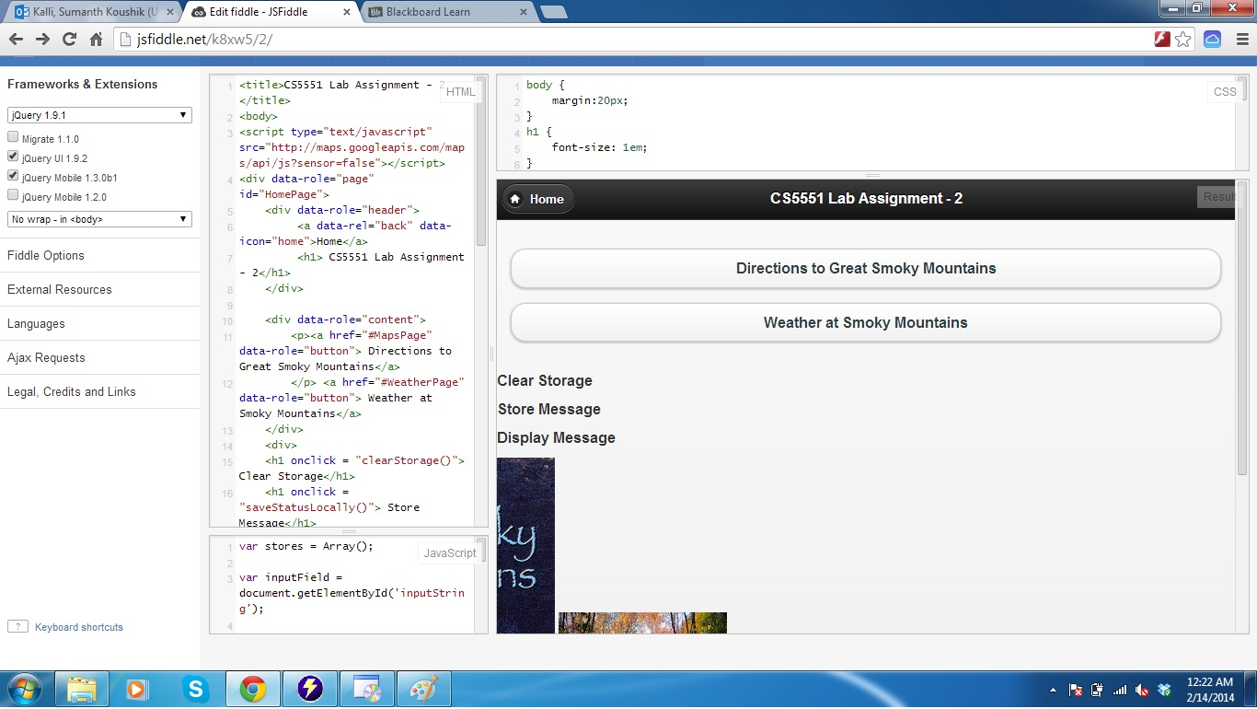

1. When anything is not stored in the application then a message “nothing stored” will be displayed.

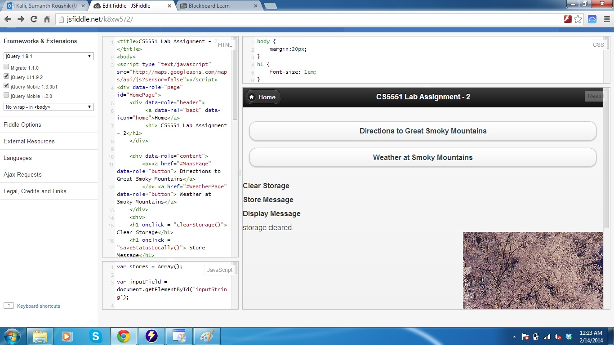

1. Also, this option is added in another page as shown below

